* Created an Azure App Service
* 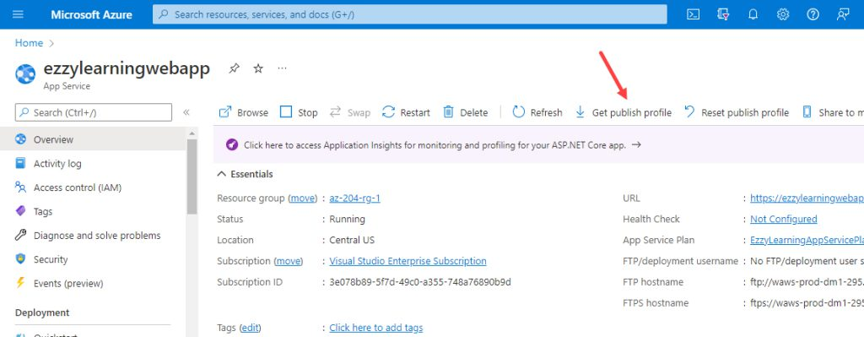Download Publish Profile from Azure Portal
* 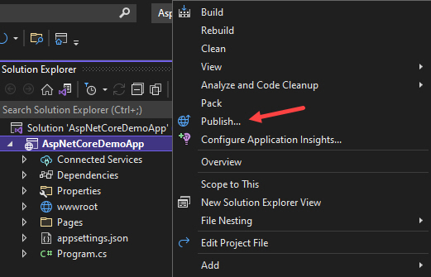Publishing Web Application to Azure App Service
* Graphical user interface, text

  Description automatically generated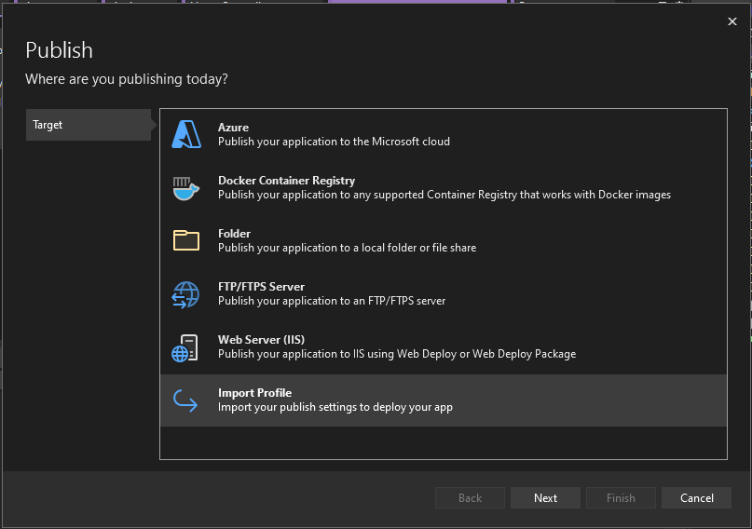Import the publish profile downloaded from the Azure portal
* VS will load and display the publishing profile settings and you will see several options to customize these settings according to your needs. You will also see subscriptions, resource, etc., and other information related to the Azure Application Service where you are deploying your application.
* Click Publish button and Visual Studio will start the process of publishing your web application.
* After published completed then launch the web app in the browser.